**Example: Advertising**

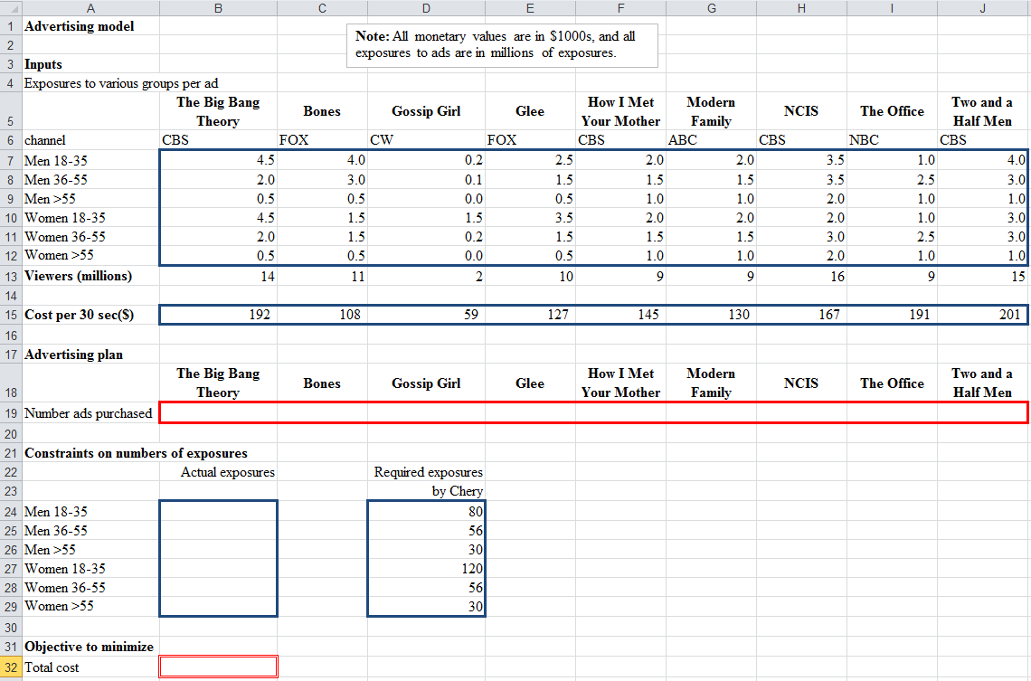**One way to set up the Chery advertising model in Excel for Solver:**

≥

=sumproduct(B7:J7,B$19:J$19)

=sumproduct(B15:J15,B19:J19)

**Using Solver:**

* From Excel menu (typically under Data), open Solver.
* Enter objective function and variable cells.
* To enter constraints, click “Add,” then enter left and right sides of constraints and type of relationship between them.
* If all variables are greater than or equal to zero, check “Make Unconstrained Variables Non-Negative.”
* Select a solving method. If model is linear, select Simplex LP.
* Click “Solve,” then “Keep Solver Solution.”

**Inputting the Advertising model into Solver:**

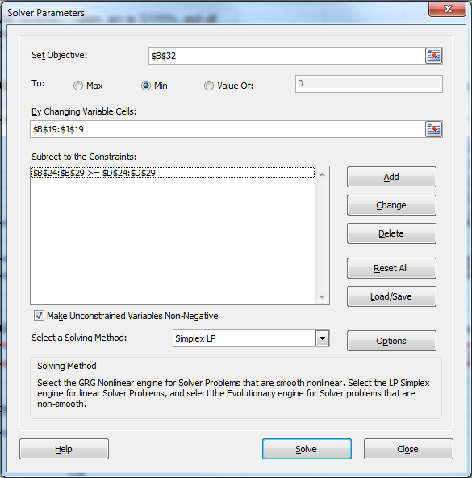

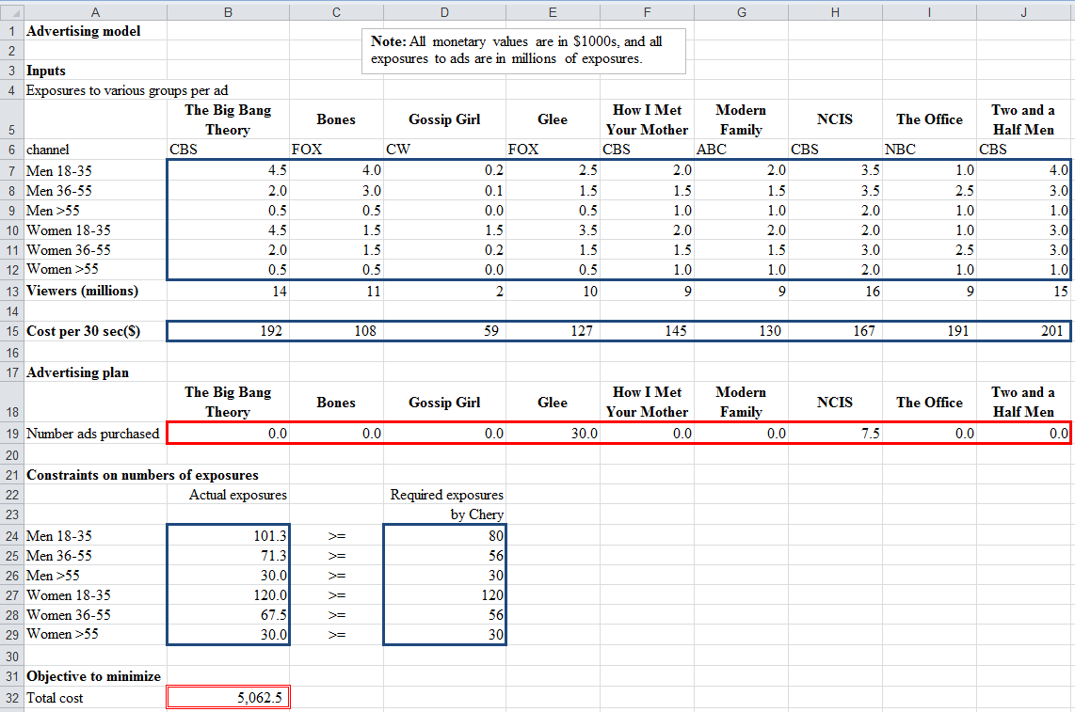**Solution to the Advertising model:**

**Integer Solution to the Advertising model:**

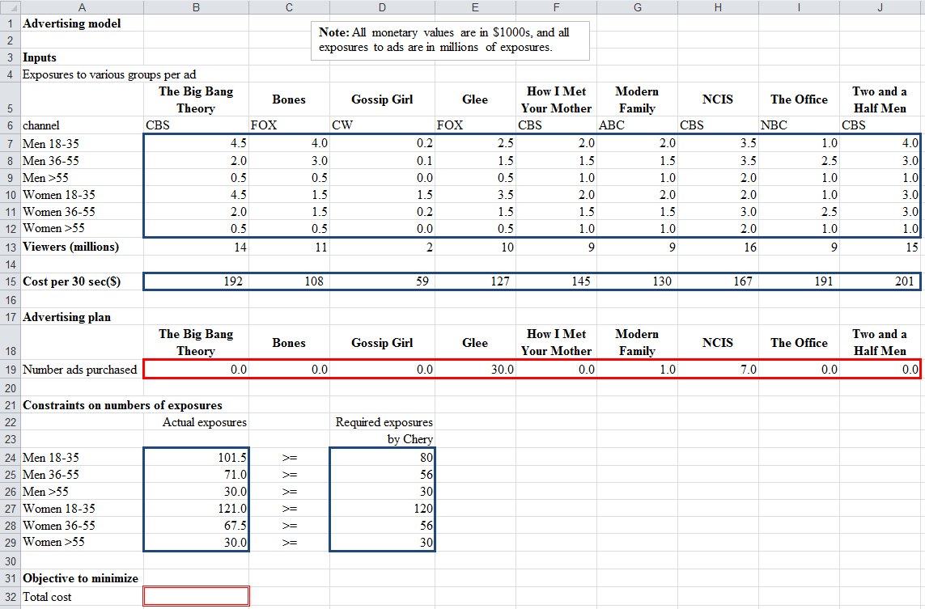Add a constraint in Solver: ________________________________________